Track Sheet Template
HUD SFXs
These sound effects are used to ensure the player knows they are interacting with a UI Button.
Source files | Editing performed | Effects applied | Comments
Pen click.mp3 | Trimmed clip to 3 complete pen clicks.  Duplicated pen click.mp3 to make 3 sound files ButtonDown, ButtonUp and Hover) | Amplified by 11.1 decibels  Pitch lowered by 3 semitones.  Low pass filter with cutoff frequency at 6000db, 12db roll off | Main sound effect for which the UI Button sounds will be based on.
ButtonUp.wav | Trimmed to remove silence | Pitch left unaltered. | Sound which plays when a button is released.
Hover.wav | Added envelope to soften attack time.  Trimmed to remove silence | Pitch raised by 6db. | Sound which plays when the player first hovers over a button.
ButtonDown.wav | Trimmed to remove silence | Lowered pitch by 6db | Sound which plays when a button is pressed.

Identify the source of the file (include a URL to the original file).  Have a separate row in the Track sheet for each Track in the project. | Describe the editing performed, e.g. cut, delete, copy, paste, clip split, join, shift, generate silence, use of envelope tool etc. | Application of effects, e.g. normalize, amplify, compression, changing speed or pitch, EQ (filters), noise gate, noise removal, voice isolation, reverb and delay etc.  You can include diagrams or screenshots of effect settings. | Identify the contribution individual tracks make to the overall sound.  Comment on your relative success in achieving your intentions.

Track Sheet Example
Grass_Footstep
Single footstep on Grass material wearing training shoes lasting one second.
Soft step with a low impact thump (reinforced with a kick drum), followed by some trailing noise (moving dirt).
Source files | Editing performed | Effects applied | Comments
740144__fossarts__stepping-on-grass-1.wav  https://freesound.org/people/FOSSarts/sounds/740144/ | Trimmed the walking sequence to a single step (Select and Delete).  Moved step to the beginning of the timeline (using the Shift clip handle). | 1. Amplify 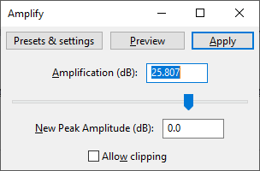  2. Fade in and out each end of the clip | Main grass footstep  Selected a single step that has a low impact thump but more grass material.  The loudest track in the mix.
foosteps_sneakers.aif  https://freesound.org/people/tim.kahn/sounds/44664/ | Trimmed the walking sequence to a single step (Select and Delete).  Moved the step thump to line up with the grass footstep on the timeline (using the Shift clip handle). | 1. Amplify 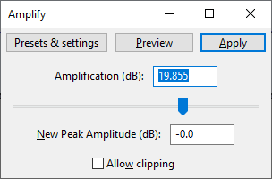  2. Fade in and out each end of the clip.  3. Added Compression to reduce the attack.  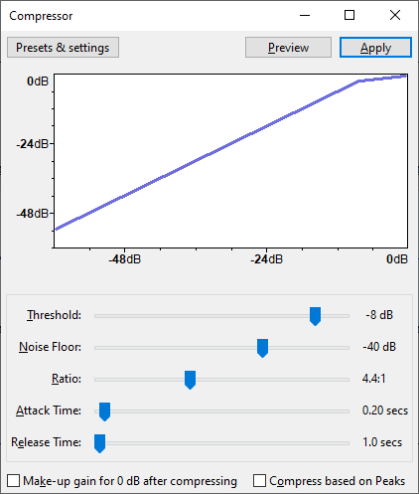 | Sound of a training shoe step.  Selected a single step that has a low impact thump but with louder rubber squeak.  Lower in the mix than the grass footstep.
132585__rob10__kick-drum-e.wav  https://freesound.org/people/Rob10/sounds/132585/ | Split clip to remove the second identical drum beat.  Moved the thump to line up with the grass and shoe on the timeline (Shift clip handle). | Did not need to Fade in and out each end of the clip as both sides were already at the minimum volume level. | Step thump. Reinforces the impact of the step but lower in the mix than the grass step track so it will not be recognisable as drum.
Dirt_Slide_02.wav  https://freesound.org/people/dheming/sounds/240977/ | Selected one section within the clip (Select, and Delete).  Used The Envelope Tool to reduce the volume of the peaks.  Moved the loudest part to line up with the grass footstep on the timeline (Shift clip handle). | 1. Amplify  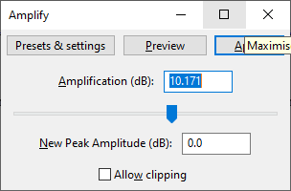  2. Fade in and out each end of the clip. | Additional trailing noise (dirt).  Low in the mix.  Does not contribute to the impact but provides some real-world texture to the step does not cut off immediately.

